**What Does Kinesiology Tape Do?**

Learn about uses, benefits, and types

By [Brett Sears, PT](https://www.verywellhealth.com/brett-sears-2695988)

Updated on July 15, 2023

 Medically reviewed by [Laura Campedelli, DPT](https://www.verywellhealth.com/laura-campedelli-pt-dpt-4776034)

Table of Contents

View All

Table of Contents

* [What the Tape Does](https://www.verywellhealth.com/kinesiology-tape-in-physical-therapy-2696435#toc-what-kinesiology-tape-does)
* [How the Tape Works](https://www.verywellhealth.com/kinesiology-tape-in-physical-therapy-2696435#toc-how-the-tape-works)
* [Using the Tape](https://www.verywellhealth.com/kinesiology-tape-in-physical-therapy-2696435#toc-how-kinesiology-tape-is-used)
* [Types of Tape](https://www.verywellhealth.com/kinesiology-tape-in-physical-therapy-2696435#toc-types-of-kinesiology-tape)
* [Applying the Tape](https://www.verywellhealth.com/kinesiology-tape-in-physical-therapy-2696435#toc-applying-the-tape)

Kinesiology tape is a sturdy, stretchy tape usually made with a blend of cotton and nylon. It is often used to help facilitate muscle function, stabilize joints, or keep muscles from contracting improperly. It can also be used to help decrease pain, swelling, and muscle spasms.

This article explains what kinesiology tape is, its uses, and the current research around it. It also explains the types of tape available, how to apply it, and when not to use it.

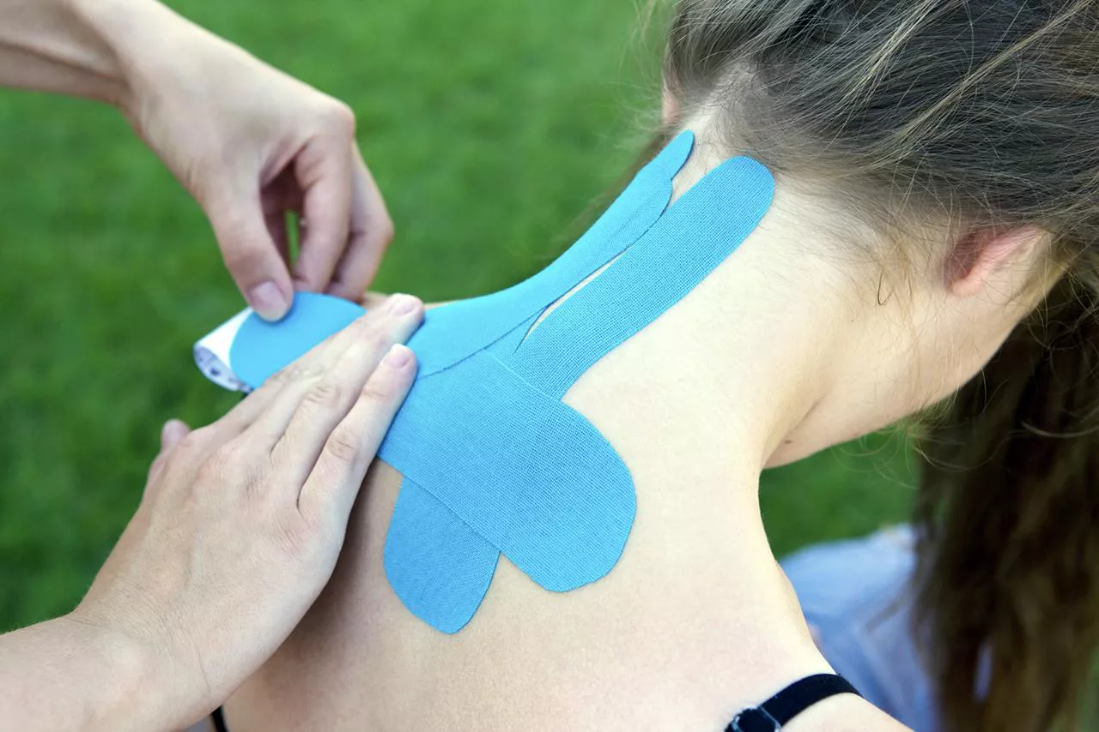

Alexander Klemm / E+ / Getty Images

Kinesiology tape was developed in the 1970s by Dr. Kenzo Kase.1 He developed many of the techniques used in kinesiology taping today and launched the Kinesio Tape brand of tape. Many other brands of the tape are now available as well.

What Kinesiology Tape Does

While kinesiology tape seems a lot like elastic athletic tape, there are differences between the two. Among them are that:

* Kinesiology tape is used to help with motion and reduce pain and spasm. Athletic tape is used for support and to limit motion, typically because of existing pain.
* Kinesiology tape is a flexible material that moves when you move. Athletic tape is relatively inflexible.
* Kinesiology tape helps to improve[lymph](https://www.verywellhealth.com/lymphatic-system-diagram-function-anatomy-diseases-5209610)transport and increase circulation. The tight binding nature of athletic tape serves to decrease circulation.

Kinesiology Tape

* Used to facilitate motion and inhibit pain
* Flexible
* Can improve circulation

Athletic Tape

* Used for support and to limit motion
* Inflexible
* Decreases circulation

How the Tape Works

There are different theories about how exactly kinesiology tape works.

One is that kinesiology tape creates balance in the neural circuitry in muscles, tendons, joints, and skin. This is thought to reduce pain and decrease swelling. It's also meant to improve muscle performance and function.2

Kinesiology tape is also thought to realign joint positions. It may also be useful in remodeling collagen tissues such as in [scar tissue management](https://www.verywellhealth.com/scar-tissue-management-2696376).3

0 seconds of 1 minute, 47 secondsVolume 90%

1:47

**Click Play to Learn How to Use Kinesiology Tape**

This video has been medically reviewed by [Casey Gallagher, MD](https://www.verywellhealth.com/casey-gallagher-md-4685028)

Research has shown that kinesiology tape may do the following:

Improve circulation and lymphatic drainage

Kinesiology tape gently lifts the superficial layers of skin, creating a space between the skin, [fascia](https://www.verywellhealth.com/what-is-fascia-5079645), and underlying tissues. This is thought to promote better circulation and [lymphatic drainage](https://www.verywellhealth.com/lymphatic-vessels-5116662), reducing swelling and inflammation.

One 2018 study concluded that kinesiotaping along with manual lymphatic draining improved congestion of lymphatic fluid after [total knee replacement](https://www.verywellhealth.com/total-partial-knee-replacement-2552271) surgeryand also improved blood circulation, relieving pain and improving functional outcomes after this type of surgery.4

Improve Proprioception

Kinesiology tape may stimulate mechanoreceptors in the skin, muscles, and joints, providing sensory feedback to the brain.

This can potentially change the [proprioception](https://www.verywellhealth.com/proprioception-2696141) input of the sensory nervous system in the muscles, joints, and skin. Proprioception is the sensation that allows you to know where your body is in space (say, how high your arm is raised).5

Normalize Muscle Tone

Kinesiology tape is also thought to inhibit [nociceptors](https://www.verywellhealth.com/what-are-nociceptors-2564616) (pain pathways) in your muscles, skin, and joint structures.6 Decreasing painful input to the brain is thought to normalize muscle tone, resulting in decreased pain and muscle spasms.

How Kinesiology Tape is Used

Kinesiology tape has many specific uses. Your physical therapist can assess your current situation and injury to decide on the best use of the tape.

Some common uses of kinesiology tape include:

* **Allowing motion:** Kinesiology tape can be used to help improve muscular firing and contraction patterns.6 This can lead to normalized muscular tone and can also help improve athletic performance.
* **Inhibition and pain management**: Kinesiology tape can be used to help decrease pain and muscle spasms that may occur after injury.7 It can help decrease your nerves' pain signals to the brain, which can help decrease muscle guarding and protective spasms.
* **Support and stability:** If you have a condition that requires a specific joint to be held in place, kinesiology taping may be right for you.5 Conditions like patellofemoral stress syndrome, [iliotibial band friction syndrome](https://www.verywellhealth.com/iliotibial-band-friction-syndrome-2696533), or shoulder instability may benefit from extra support provided by kinesiology tape. The tape can support your joint while still allowing for some motion.
* **Decreasing swelling**: If you have had swelling from an injury or surgery, kinesiology tape may help decrease the swelling by decreasing pressure between the skin and underlying tissues. This provides a pathway for excess fluids to travel through. Kinesiology tape is sometimes used in lymphedema management or for superficial contusions (bruises).8
* **Scar tissue management**: After surgery or trauma, you may have a scar over the area that was injured. Sometimes the tissue underneath the scar binds to your skin and underlying fascia. This scar tissue can limit your normal mobility and [range of motion](https://www.verywellhealth.com/overview-range-of-motion-2696650). Kinesiology tape can be used to gently pull on scar tissue, providing a low-intensity, long-duration stretch to the tight collagen that makes up scar tissue.3

Types of Kinesiology Tape

Kinesiology tape can be applied in different ways, depending on why it's needed. Your physical therapist can show you how to use the tape and cut the adhesive strips into the right configuration.

Tape shapes include:

* **The "I" strip**: This shape can be used to make the other types of strips below. Typically "I" strips are used to support muscles, tendons, and ligaments. They are often used to facilitate your rotator cuff, [gluteus muscles](https://www.verywellhealth.com/gluteus-medius-muscle-anatomy-2696374), quadriceps, or Achilles' tendon.9 It can also be used on your low back and middle back to help you maintain proper posture.
* **The "X" strip**: This type is used when kinesiology tape is needed to cover a large area or cross multiple joints. The tabs of the "X" strip cross over sensitive areas such as the back of your knees or front of your elbows. This strip is commonly used to facilitate your [hamstrings](https://www.verywellhealth.com/hamstring-muscles-296481), which cross both your hip joint and the back part of your knee joint.9
* **The "Y" strip**: This strip is used to cross sensitive areas of your body such as behind your knee or in the front of your elbow. It is also commonly used for applications to control the position of your kneecap as in [patellofemoral stress syndrome](https://www.verywellhealth.com/knee-pain-from-patellofemoral-stress-syndrome-2696537) or a subluxing patella. The "Y" strip is typically not as long as the "X" strip.10
* **The "fan" strip**: This type can help control swelling of your leg or arm. It is commonly used in lymphedema management or for superficial contusions and swelling.8
* **The "lift" strip**: Commonly referred to as the Band-Aid, this strip is often used to support injured tissues or to treat muscle knots or trigger points. It helps to lift skin and tissues off of sore muscles and trigger points. It is also used to treat superficial bruises.6

Your therapist or sports medicine provider can ensure that you're placing the tape in the proper position and that the tape is not too tight or restrictive. They'll also let you know how long to wear the kinesiology tape.

Brands and Where to Buy

There are over 50 different types and brands of kinesiology tape on the market today, such as Kinesio Tape, KT Tape, or RockTape. Some specific tapes are designed for sports performance, and others are designed for lymphedema and swelling management.

According to the Kinesio Tape manufacturer, the tape colors don't represent any chemical or physical differences. They're a matter of personal preference.11

Kinesiology tape is available at retail stores and pharmacies, as well as some sporting goods stores. It's also sold online. The cost varies by brand and where you buy it, but some stores have a generic "house" brand that may be more affordable.

Applying the Tape

Before you start using Kinesio tape, your physical therapist will perform an evaluation and assessment to determine the best use of it for your condition. They will assess whether the tape is necessary for you or if you have any contraindications to using the tape.

Here are step-by-step instructions for applying the tape.

1. **Clean your skin.** Clean the area of the skin where you'll be applying the tape. Make sure the skin is dry and free from lotions, oils, or sweat. You may also need to shave the area if you have hair in that spot. 12
2. **Measure and cut:** Measure the length of tape you'll need to cover the area you want to support or the muscle you want to target. Cut the tape, rounding the corners of the tape to prevent the corners from coming up.
3. **Activate the adhesive:** Depending on the brand or type of tape, there may be specific instructions for activating the adhesive. In general, you'll need to rub the tape with your hands or apply light heat (such as with a hairdryer) to activate the adhesive before applying it to the skin.
4. **Apply the tape:** Gently apply the tape to the desired area, stretching it as instructed by the specific technique you are using. It's essential to follow specific taping patterns or techniques recommended for your condition or goal.
5. **Smooth and rub the tape:** Smooth the tape onto the skin using your hand, starting from the center and moving outward. Rub the tape to ensure it adheres well to the skin.

The tape is water-resistant and strong enough so that you can keep it on for three to five days while going about your usual activities. However, some researchers recommend not leaving the tape on for more than 24 hours at a time.12

How to Remove the Tape

To remove the tape without hurting your skin:

1. Apply oil (such as baby oil or olive oil) or lotion on top of the tape to loosen the strip.
2. Remove the tape slowly. Don't rip it off.
3. Press down on your skin to separate it from the tape.
4. Pull the tape back against itself, rather than straight up away from you. Compress your skin gently while pulling the tape back in the direction of the end tab.

Does It Really Work?

More research needs to be done to understand the mechanisms of how the tape works and if it truly lives up to its claims.

Recent studies have shown that the use of kinesiology tape can improve muscular contractions in the vastus medialis, a specific part of the [quadriceps muscle](https://www.verywellhealth.com/what-are-the-quadriceps-muscles-2696379) responsible for controlling the position of your kneecap.13 They've also demonstrated an improved range of motion in the lower back, immediately after the application of kinesiology tape.14

To support the use of kinesiology tape to improve athletic performance, RockTape conducted a study of five cyclists and found that they performed 2% to 6% better with the application of kinesiology tape (specifically RockTape) than without the tape.15 However, this study may be biased, with RockTape as its sponsor and only five athletes with no control group.

Other studies have examined the effect of kinesiology taping and pain, swelling, and improved mobility, with varied results.16

Lee K, Yi CW, Lee S. [The effects of kinesiology taping therapy on degenerative knee arthritis patients' pain, function, and joint range of motion](https://doi.org/10.1589/jpts.28.63). *J Phys Ther Sci.* 2016;28(1):63-6. doi:10.1589/jpts.28.63

**Who Should Not Use Kinesiology Tape?**

Some people, including those with open wounds, infections, or skin allergies, should not use kinesiology tape. It's also not recommended if you have health conditions such as [diabetes](https://www.verywellhealth.com/diabetes-mellitus-7944909), stroke, [deep vein thrombosis](https://www.verywellhealth.com/deep-vein-thrombosis-overview-2223680), or [cancer](https://www.verywellhealth.com/cancer-overview-4581995).

[Should You Avoid Using Kinesiology Tape?](https://www.verywellhealth.com/should-you-avoid-using-kinesiology-tape-2696036)

Summary

Kinesiology tape is a type of stretchy tape made of cotton and nylon. It is applied to the body in different ways to reduce swelling and pain from an injury, increase mobility, and prevent muscle spasms.

It is important to apply and remove the tape properly. A physical therapist can help with this as well as advise you on how and when you should be using it. People with certain health problems should not use kinesiology tape.

**Frequently Asked Questions**

* Does kinesiology tape boost athletic performance?

Some studies do show that using the tape on injured areas can help reduce pain, but it's unclear whether the pain reduction is significant.17 There isn’t strong evidence that it enhances performance in healthy athletes, as some have claimed.

Learn More [Using Kinesiology Tape for Shoulder Injuries](https://www.verywellhealth.com/support-your-shoulder-with-kinesiology-tape-2696040)

* Are there drawbacks to using kinesiology tape?

It’s possible to cause blisters or tears on the skin if you tape an area too tightly. If the tape isn’t applied in the right direction and with the right amount of stretch, it may not be effective. A professional should put the tape on and teach you how.

Learn More [What to Expect in Sports Medicine Physical Therapy](https://www.verywellhealth.com/what-to-expect-from-pt-during-the-first-appointment-2696665)

* Can you shower when you have kinesiology tape on?

Yes. The tape should last three to five days on your skin even with showering.

Learn More [Kinesiology Tape Can Prevent Nipple Irritation](https://www.verywellhealth.com/should-you-avoid-using-kinesiology-tape-2696036)